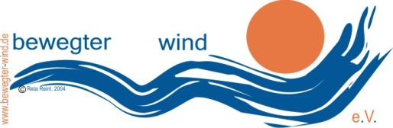
bewegter wind e.V.
Reta Reinl (Kuratorin)
mail@bewegter-wind.de
Tel. 06454-1445
www.bewegter-wind.de

press release
10.1.2018

Freedom, forms and transformation:
Announcement of the art competition "bewegter wind 2018"

Northern Hesse (Zierenberg / Habichtswald). "Clouds " is the theme of the 9th Wind Art Festival" bewegter wind ", which will take place from 19 August, 19th to September, 2nd, 2018 in Northern Hesse. Whether wind art objects, installations, videos or performances: artists from all over the world are invited to present themselves at this unique art event. The exhibition venues Zierenberg and Habichtswald are located in the immediate vicinity of Kassel, in the heart of Germany. The fascinating mountain landscape with Celtic sites, forests and lakes as well as the medieval town of Zierenberg offers a wide variety of outstanding exhibition opportunities. The wind art festival "bewegter wind" is accompanied by a theme-related supporting programme that invites visitors to discover landscapes and exhibits.

Artists are invited to submit their ideas on the competition theme "Clouds" by April the 9th, 2018. On August 13th, the public week of installation construction starts. The opening of the event will take place on 19th of August. The award ceremony will conclude the "moving wind 2018" on 2 September. The prize money is 3,500 euros for the first place, 2,500 euros for second place and 1,500 euros for third place.
The organizer of the ideas competition and the exhibition is "bewegter wind e. V. - registered association for the promotion of wind art and intercultural communication. The curator is once again the artist Reta Reinl, who has been playing a major role in the organisation of the international wind art festival for 13 years. Partners and supporters are the County of Kassel, the Nature Park Habichtswald, the city of Zierenberg and the community of Habichtswald.

Countless possibilities for “cloud art”.
The term "clouds" is complex and interdisciplinary. In meteorology, clouds are defined as an accumulation of water and ice. Water droplets are formed around condensation cores, solar rays make them visible, the sun and wind set them in motion. Their variety of shapes is almost limitless. The shape of a cloud is constantly changing - not only due to the wind, but also in the context of the landscape surroundings. Meteorology distinguishes between the following cloud types: Stratus, Cumulus and Cirrus. All cloud forms can occur all over the world. Whether Sahara sand or environmental toxins - what do clouds actually transport?
In a metaphorical sense, the cloud can stand for freedom and boundlessness. It is indeterminate and open to change. Cloud formations are momentary images that are always exposed to transformation and transgression. Clouds can be interpreted as a symbol for a place of longing. The spectrum ranges from the cheerful cloud of fair weather to the threatening storm front. Thus the sky becomes a stage for drama and fantasy: emerge, change, die. Cloud language is international.
The cloud as a knowledge storage: An IT cloud has a defined location, although it is perceived as virtual. It is a repository for information, knowledge and history. Cloud computing distinguishes between private, shared, public and hybrid "storage spaces".
The social cloud is a group defined by common experiences, values, attitudes and opinions. Sometimes the social cloud hinders the view to the sky and horizon and hides the perspective of the whole. At the same time, it gives home in endless digital space.

Clouds as objects of artistic reflection
Where are the similarities of the "cloud meanings" and where do the opposites lie? Is there a cloud home? Does the social group - the crowd- condense into a cloud, because the lines between virtual and real are blurring more and more? How can a constant change become tangible and be presented? And how do cloud-cuckoo-land actually come into being? Is it possible to build cloud boundaries against non-European flight clouds?
The "bewegter wind e. V." is looking forward to artistic answers in the form of wind objects, installations, performances and Landart in the broadest sense. Diverse and creative ideas, lateral thinkers from all fields of art are welcome. The organizers will also be looking for ways to realise unusual contributions together with the artists.
Details on the announcement with technical and legal information can be found here: www.bewegter-wind.de/ downloads/ announcements
Background information / Info box:
Art. Nature. Wind.
The wind art festival "bewegter wind" takes place every two years at changing locations in the region of Northern Hesse. The landscape exhibition combines art competition, international artists' meetings and cultural exchange. The varied supporting programme includes guided tours of the exhibition as well as a children's programme. Wind objects, installations, performances and videos make it possible to experience art and nature in special landscape situations. To date, 549 works of art have been exhibited at 29 locations in Northern Hesse - 450 artists from 35 countries have participated.
Text: Liane Linke 01/10/2018

Photos in high resolution attached or to download hier:
http://bewegter-wind.de/de/downloads/category/5-presseinformationen

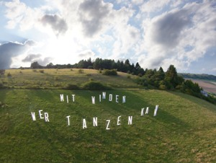
Photo 1 shows an installation of Michael Klant
“Wer tanzen kann mit Winden“
Title: bw16--MichaelKlant-Wer-tanzen-kann-mit-WindenBuchstabeninstallation_Luftfoto: Michael Klant

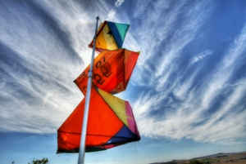
Photo 2 shows an wind object of Marcel Kopp: dusk, 2016

Title: bw16-Marcel-Kopp--2249_50_51-F- Foto: UweThon

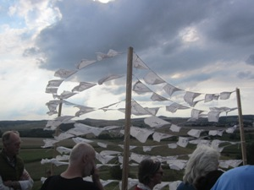
Photo 3 : „Windtower“ oft he arab artist Amna Al Dabbagh, 2016

Title:bw16-AmnaAlDabbagh-Windtower—Foto: Britta-Ischka

